Homework 4A*
Your First Astrobites Article - Exomountains
Reading Due: Wednesday, October 14 by 11am
Answers Due: Monday, October 19 by 11:59pm

One of the aims of Pre-MAP is to develop your skills reading and writing about science. Astrobites is a website where graduate students write summaries of recently published research articles at a level aimed for undergraduate students. Reading papers can be difficult, they are often written in a pretty dense style and use a lot of discipline-specific jargon. Even professional astronomers need to Google terms and look things up, so don’t worry if you find some terms or concepts you’re not familiar with in this summary.

To dip our toes into reading scientific papers, you will first read the astrobites summary of a paper that was published in the Monthly Notices of the Royal Astronomical Society (MNRAS), a popular journal where astronomers publish their scientific findings.

Assignment outline:
- Watch this video. This is a 7 minute YouTube video by Moiya McTier (the lead author of the paper you’re reading today) that will give some really useful overview of the paper that will help make the reading easier to follow.
- Read through this astrobites article. Take your time and feel free to look up any words you don’t know, or write down questions to ask in class (you can write them down directly on this Google doc if you like!). We’ll spend some time in class on October 8 going over the article and discussing any concepts/terms you want explained.
- Answer the questions below
- Check out the author highlight
- Don’t forget to also complete Homework 4B, the coding portion. The coding portions of your homeworks can be found in your PreMAP2026 directory. The path to this homework assignment is PreMAP2026/homework/HW4/. You will complete your coding homework in the Jupyter notebooks provided and turn them in using the directions in the homework notebook. *Don’t forget to change the name of the homework so it doesn’t get overwritten when you git pull.

Questions: (please write your answers directly on this document in the space below each question)

- What is an exoplanet?

- Which method was used to detect the exoplanets in this paper? Give a brief explanation for how it works.

- The transit depth is essentially how much the host star is dimmed when the planet passes in front. Which physical properties of the host star and the planet determine the depth of the transit? Please include the equation from the reading that relates these quantities mathematically.

- Figure 1 shows a light curve, or a plot that shows how much light is being detected from the host star as a function of time. If you need help understanding what is physically going on at each point in the figure, please check out this quick video that shows a planet passing in front of its host star, and draws out the light curve in real time. Below, you will see Figure 1 with four regions separated by dashed lines, A, B, C, and D.
  - Which region corresponds to the point where the planet is fully in front of the star, but is not showing any mountainous or “bumpy” features?

  - Which region corresponds to the planet starting to pass in front of the star?

  - Which region corresponds to the planet not yet in front of the star at all?

  - Which region corresponds to the planet fully in front of the star, and showing mountainous or “bumpy” features?

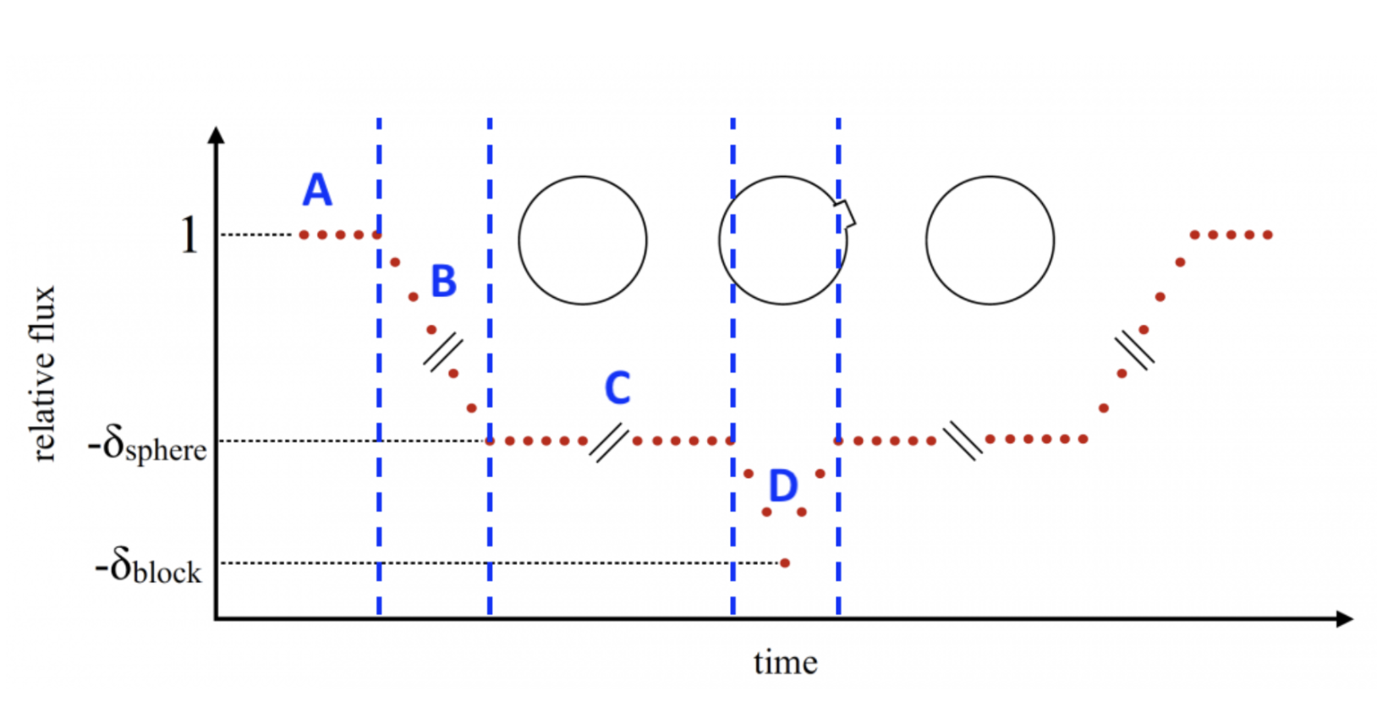
- Why can you see features on the planet’s surface only during some points in its transit rather than the whole transit duration?

- Based on Figure 2 and the description in the text, why would a bumpier planet have a higher scatter in its transit depth?

- Which is bumpier, wet or dry Earth? Why?

- What are some sources of false positives in detecting bumpiness on exoplanets?

- Why would this method not work if the planet is tidally locked?

Author Highlight
Why highlight the author? Throughout Pre-MAP we will be reading papers to help build the science literacy skills necessary for scientific research. We will also be highlighting contributions by astronomers who have traditionally been under-represented in astronomy such as women, people of color, people from low income backgrounds, first generation college students, and those at the intersections of these groups. The goal is simple: representation matters!


Moiya McTier is a Ph.D. candidate in astronomy at Columbia University in New York. Before starting graduate school, she majored in astrophysics and folklore & mythology at Harvard University. She grew up in a small Pennsylvania coal-mining town, where she developed her love of storytelling. She is passionate about science communication, has written a science fiction novel, and has given more than 100 talks on science and equity & inclusion in astronomy. Here’s a link to her website.

